Frequently Asked Questions
- How do I get started with a Lions Club contract?
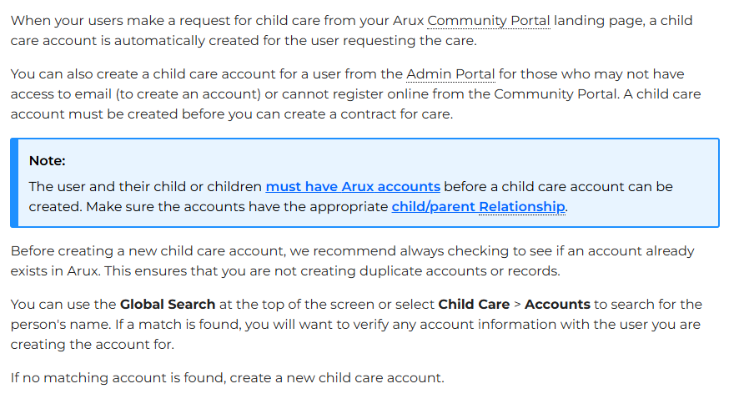
Click here to be directed to the website.

- How much is Lions Club?
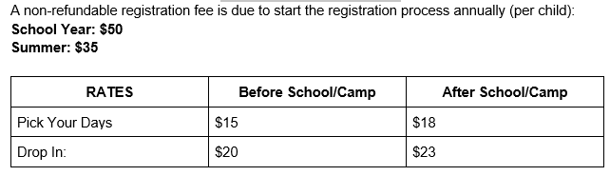

- What time does Lions Club start before care?
School Year: Between 7:00 AM – 8:30 AM
Summer: Between 7:30 AM – 8:45 AM

- What time does Lions Club end for after care?
Lions Club closes promptly at 5:30 PM. A five-minute grace period is provided, but starting at 5:35 PM, a $5 per minute late fee will be charged to your account. Frequent late pick-ups may result in removal from the program.

- Is Lions Club offered to all Orange camps during the summer?
Lions Club is only offered to full day camps that start at 9:00 AM and end at 3:00 PM.

- What do the kids do in Lions Club?
Before School Care: The children have the option between free play, creative thinking, and active play in the gym and playground. Computer time is allowed for active brain games.
After School Care: The children are greeted with a snack and juice once they arrive. The afternoon consists of active brain games on the Chromebook, optional homework time, structured social and recreational activities, occasional Cuyahoga Librarian visits, outdoor play, and gym time. Some activities consist of rainbow looms, friendship bracelets, table tennis, Lego building, toys the children can play with, and fuse beads.

Before Camp Care: The children have the option between free play, creative thinking, and active play in the gym and playground.
After Camp Care: The children are greeted with a snack and juice once they arrive. The afternoon consists of unstructured social and recreational activities, outdoor play, and swim time.

- Can I pack extra snacks for my child?
Yes, you can pack extra snacks for your child to eat in Lions Club.

- Is breakfast included in before care?
No, breakfast is not included with before care. You are more than welcome to pack something easy for your child to eat in the morning.

- What’s the difference between “Pick Your Days” and “Drop in Days”?
Pick Your Days: You must modify your child’s schedule by Thursday afternoon of each week for the following week. If you notice an error in your invoice or no longer need a day that’s on the invoice you can send us an email by Friday, 4:00 pm to get the Pick Your Days rate.

Drop-In Days: Drop-In days are based on the availability in the program. You must request the day before 2:00 pm to ensure all parties are notified that your child will get to the correct place at the end of the day. Confirmation is required.

- Will I be charged for the days I have chosen but my child did not attend?
Yes, you are billed at the beginning of the week. We staff based on the numbers in our program on Friday.

- Who can be an authorized pick up? Can the authorized pick ups be changed?
An authorized adult (18 years or older) must be listed on the pick-up list on your child’s account. Yes, you can update this information on your Arux account or contact the Rec office to update the authorized pick-ups.

- How does the teacher know where to send my child at dismissal?
School Dismissal Manager is an app that needs to be updated to notify the teachers where to send the children. It’s very important to have this updated before 2:00 PM.

- How do I get access to my childcare tax statements?
https://guide.arux.app/docs/printing-your-tax-statements

- Who do we contact if we have questions for Lions Club?
Briana Hustak : Bhustak@orangecsd.org : 216-831-8605

